Midsegment Theorem

Definition
# Source: AI Source: Provided by: [Data Path: Persons Table -> ID Column: 1, Name_En Column: Motasem Essam] -> From: [ChatGPT] on [7/25/2026]
The Midsegment Theorem states that a segment connecting the midpoints of two sides of a triangle is:
- Parallel to the third side.
- Half the length of the third side.
Consider triangle $ABC$. If $D$ is the midpoint of $AB$, and $E$ is the midpoint of $AC$, then:
$$\boxed{DE∥BC}$$
and:
$\boxed{DE=\frac{1}{2}BC}$
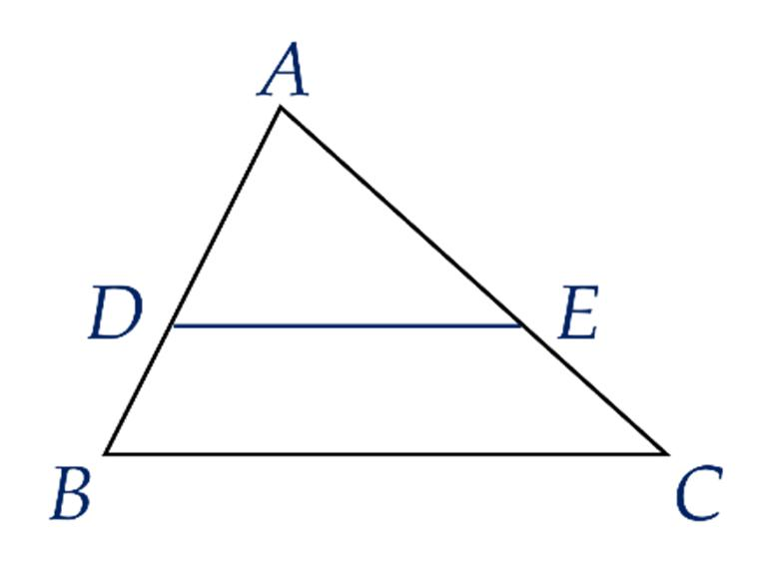
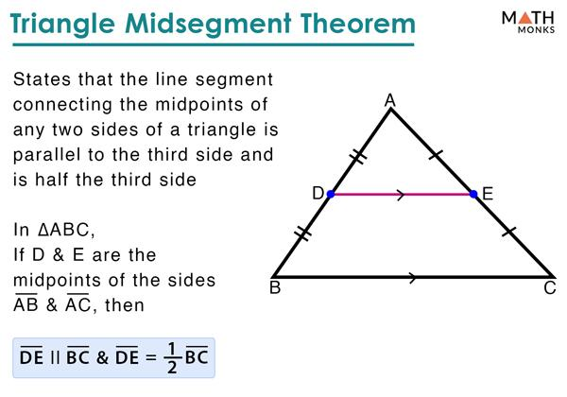
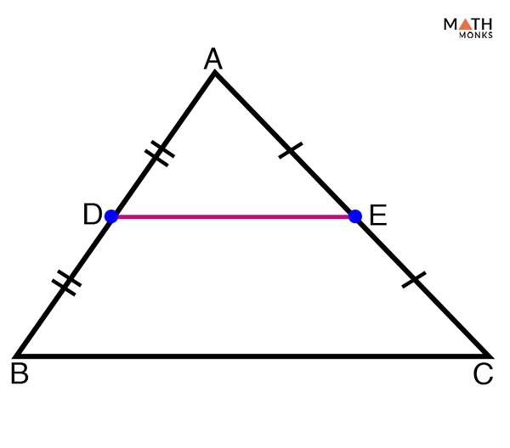

Purpose
# Source: AI Source: Provided by: [Data Path: Persons Table -> ID Column: 1, Name_En Column: Motasem Essam] -> From: [ChatGPT] on [7/25/2026]
The Midsegment Theorem is used to:
- Find unknown lengths in triangles.
- Establish parallel lines.
- Determine the length of a segment connecting two midpoints.
- Solve problems involving proportionality.
- Support geometric proofs.
- Connect triangle geometry with parallelism and similarity.

Basic Configuration
# Source: AI Source: Provided by: [Data Path: Persons Table -> ID Column: 1, Name_En Column: Motasem Essam] -> From: [ChatGPT] on [7/25/2026]
Consider triangle $ABC$.
Let:
$$D=\text{midpoint of }AB$$
and:
$$E=\text{midpoint of }AC$$
Therefore:
$$AD=DB$$
and:
$$AE=EC$$
Connect $D$ and $E$.
The segment $DE$ is called a midsegment.
The theorem states:
$$\boxed{DE∥BC}$$
and:
$\boxed{DE=\frac{1}{2}BC}$
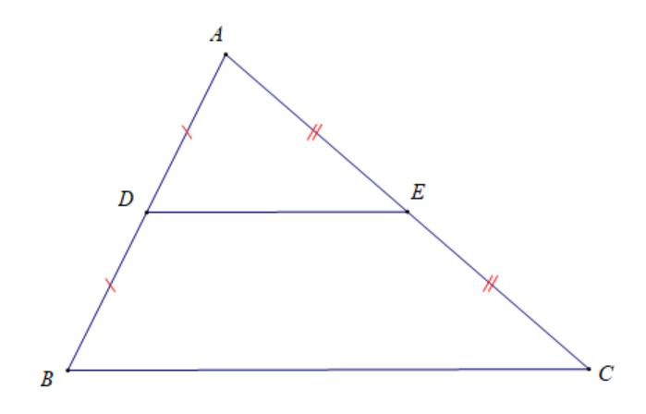
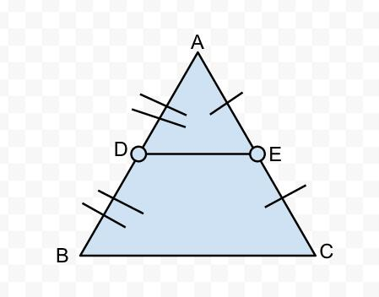
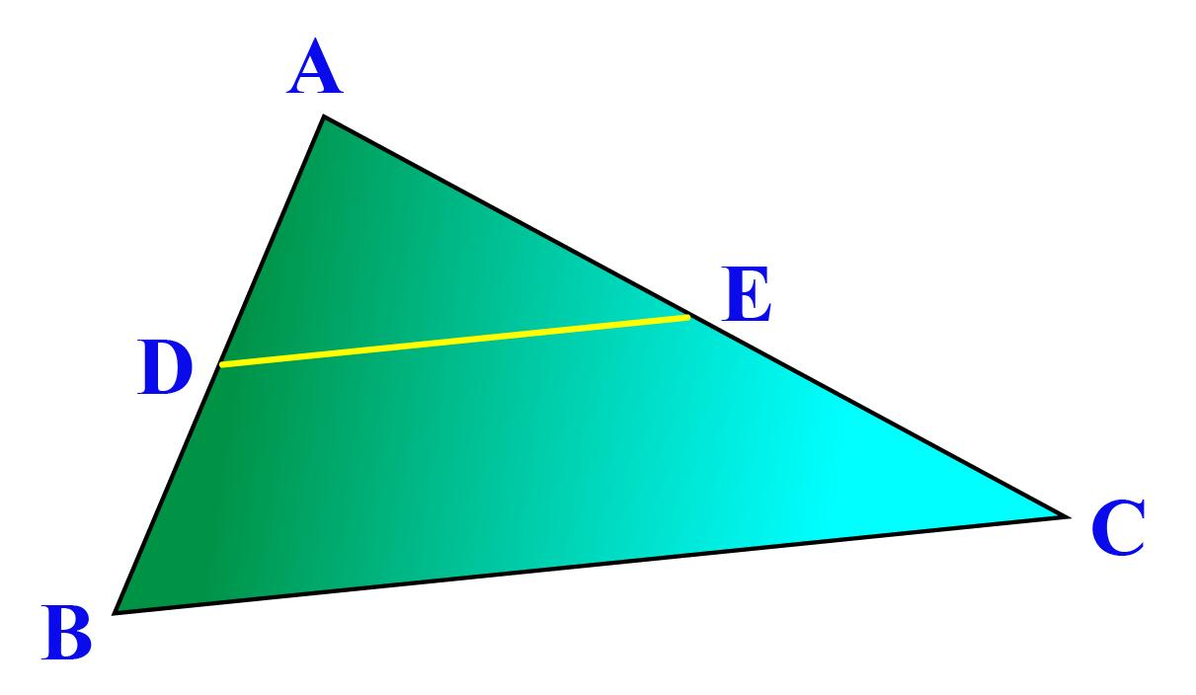

Mathematical Representation
# Source: AI Source: Provided by: [Data Path: Persons Table -> ID Column: 1, Name_En Column: Motasem Essam] -> From: [ChatGPT] on [7/25/2026]
If:
$$AD=DB$$
and:
$$AE=EC$$
then:
$$\boxed{DE∥BC}$$
and:
$$\boxed{DE=\frac{1}{2}BC}$$
Therefore:
$$\boxed{BC=2DE}$$

Example 1 — Finding the Midsegment
# Source: AI Source: Provided by: [Data Path: Persons Table -> ID Column: 1, Name_En Column: Motasem Essam] -> From: [ChatGPT] on [7/25/2026]
Suppose:
$$BC=20$$
Since $DE$ is a midsegment:
$$DE=\frac{1}{2}BC$$
Therefore:
$DE=\frac{1}{2}(20)$
$$\boxed{DE=10}$$

Example 2 — Finding the Third Side
# Source: AI Source: Provided by: [Data Path: Persons Table -> ID Column: 1, Name_En Column: Motasem Essam] -> From: [ChatGPT] on [7/25/2026]
Suppose:
$$DE=7$$
Using:
$$DE=\frac{1}{2}BC$$
we get:
$$7=\frac{1}{2}BC$$
Multiply both sides by $2$:
$$\boxed{BC=14}$$

Example 3 — Identifying Midpoints
# Source: AI Source: Provided by: [Data Path: Persons Table -> ID Column: 1, Name_En Column: Motasem Essam] -> From: [ChatGPT] on [7/25/2026]
Suppose:
$$AB=18$$
and $D$ is the midpoint of $AB$.
Then:
$$AD=DB$$
Therefore:
$AD=DB=\frac{18}{2}$
$$\boxed{AD=DB=9}$$
If $E$ is the midpoint of $AC$, then $DE$ is a midsegment and:
$$DE∥BC$$

Why Is It Half the Third Side?
# Source: AI Source: Provided by: [Data Path: Persons Table -> ID Column: 1, Name_En Column: Motasem Essam] -> From: [ChatGPT] on [7/25/2026]
Since $D$ and $E$ are midpoints:
$$\frac{AD}{AB}=\frac{1}{2}$$
and:
$$\frac{AE}{AC}=\frac{1}{2}$$
The smaller triangle $ADE$ is similar to the original triangle $ABC$:
$$\boxed{△ADE∼△ABC}$$
The scale factor is:
$$\frac{1}{2}$$
Therefore:
$$\boxed{\frac{DE}{BC}=\frac{1}{2}}$$
so:
$\boxed{DE=\frac{1}{2}BC}$
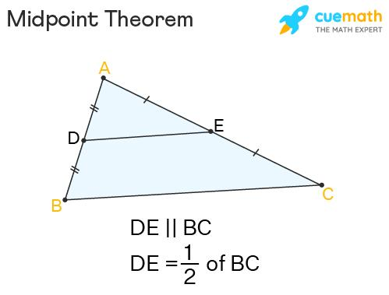
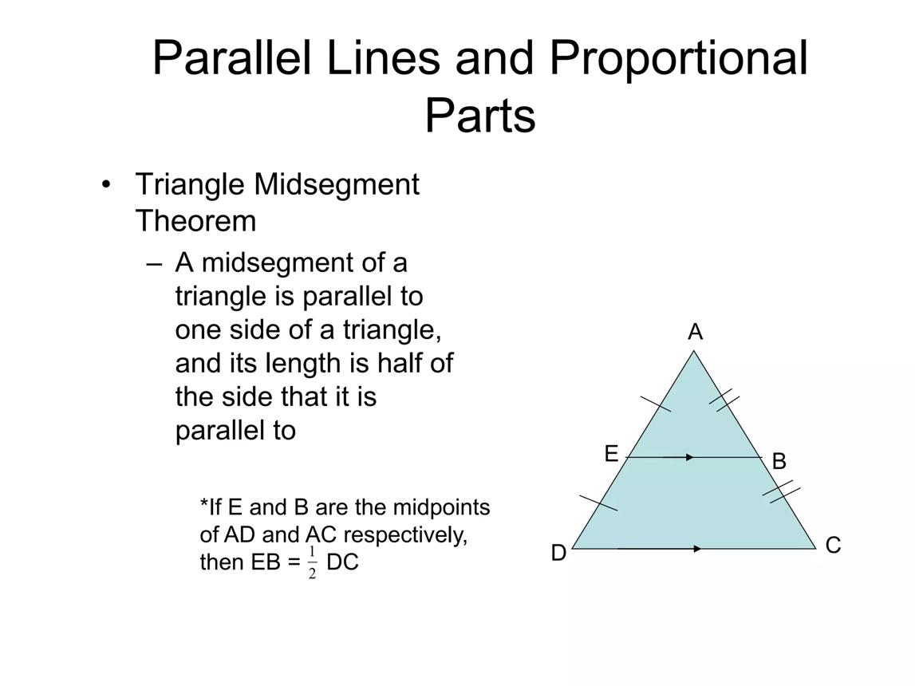
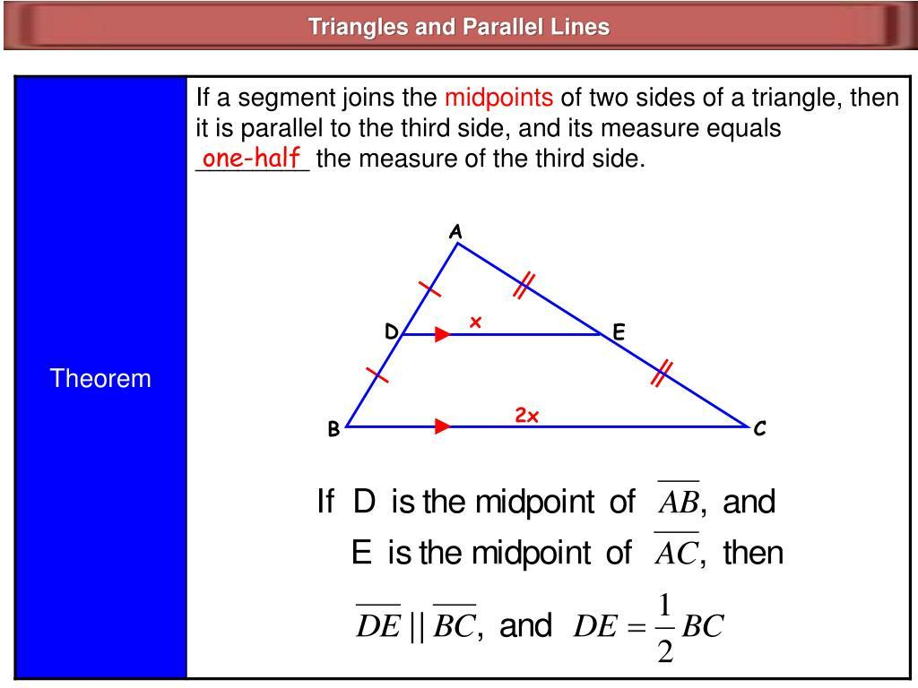

Proof of the Midsegment Theorem
# Source: AI Source: Provided by: [Data Path: Persons Table -> ID Column: 1, Name_En Column: Motasem Essam] -> From: [ChatGPT] on [7/25/2026]
Consider triangle $ABC$, where:
$$D=\text{midpoint of }AB$$
and:
$$E=\text{midpoint of }AC$$
Therefore:
$$\frac{AD}{AB}=\frac{1}{2}$$
and:
$$\frac{AE}{AC}=\frac{1}{2}$$
Thus:
$$\frac{AD}{AB}=\frac{AE}{AC}$$
By the Triangle Proportionality Theorem:
$$\boxed{DE∥BC}$$
Because the corresponding sides of the similar triangles are proportional:
$$\frac{DE}{BC}=\frac{AD}{AB}$$
Therefore:
$$\frac{DE}{BC}=\frac{1}{2}$$
and:
$$\boxed{DE=\frac{1}{2}BC}$$

Converse of the Midsegment Theorem
# Source: AI Source: Provided by: [Data Path: Persons Table -> ID Column: 1, Name_En Column: Motasem Essam] -> From: [ChatGPT] on [7/25/2026]
The theorem also has a useful converse-related relationship.
If a segment passes through the midpoint of one side of a triangle and is parallel to another side, then it intersects the third side at its midpoint.
For example, if:
$$D=\text{midpoint of }AB$$
and:
$$DE∥BC$$
then $E$ is the midpoint of $AC$:
$$\boxed{AE=EC}$$
This is sometimes called the converse of the triangle midsegment theorem.

Three Midsegments of a Triangle
# Source: AI Source: Provided by: [Data Path: Persons Table -> ID Column: 1, Name_En Column: Motasem Essam] -> From: [ChatGPT] on [7/25/2026]
A triangle has three possible midsegments.
Each midsegment connects the midpoints of two sides and is parallel to the third side.

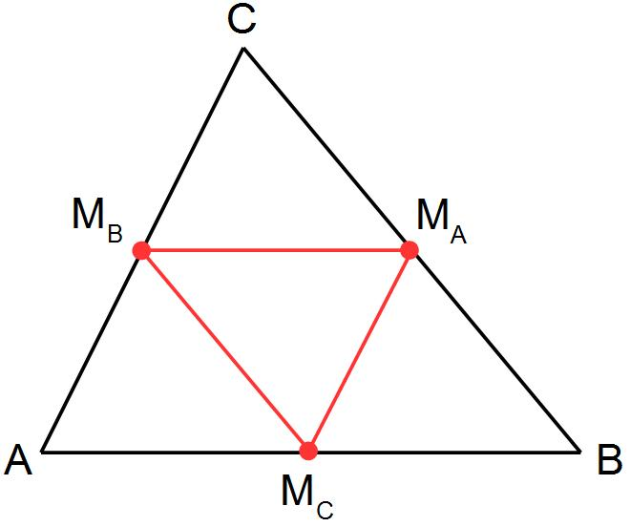
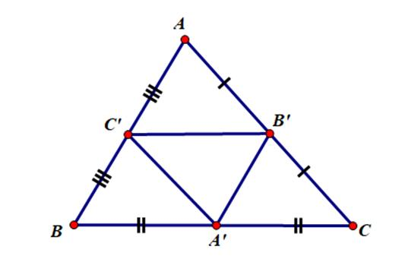
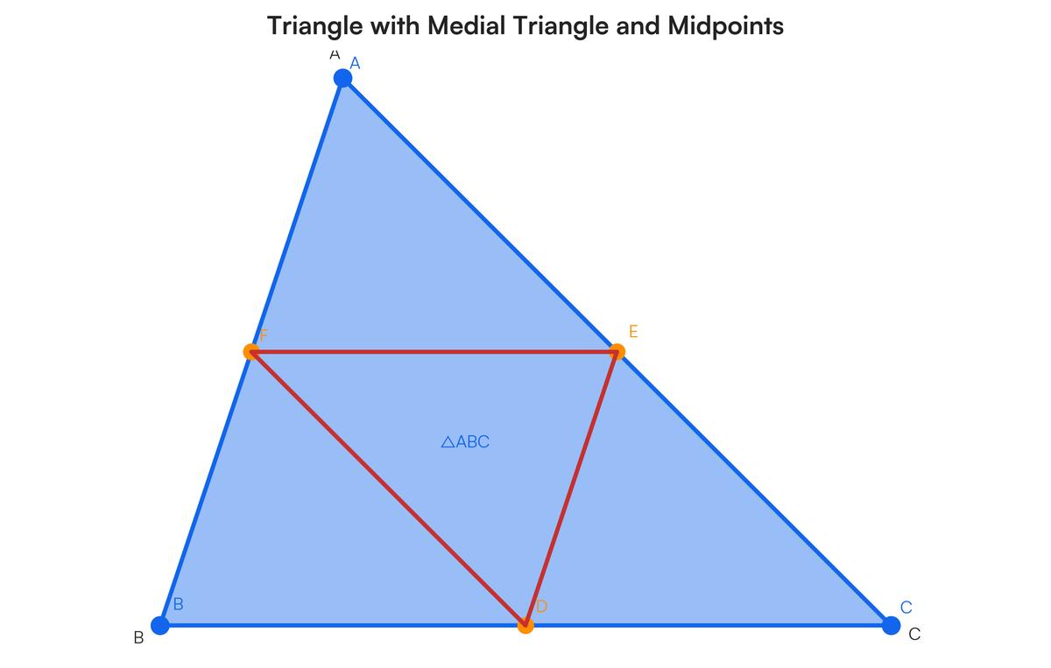
If all three midsegments are drawn, they form a smaller triangle called the medial triangle.
Each side of the medial triangle is:
$$\boxed{\frac{1}{2}}$$
the length of the corresponding side of the original triangle.

Relationship with the Triangle Proportionality Theorem
# Source: AI Source: Provided by: [Data Path: Persons Table -> ID Column: 1, Name_En Column: Motasem Essam] -> From: [ChatGPT] on [7/25/2026]
The Midsegment Theorem is closely related to the Triangle Proportionality Theorem.
For example:
$$\frac{AD}{DB}=1$$
and:
$$\frac{AE}{EC}=1$$
Therefore:
$$\frac{AD}{DB}=\frac{AE}{EC}$$
This proportional relationship establishes:
$$\boxed{DE∥BC}$$
The Midsegment Theorem can therefore be understood as a special proportional relationship created by midpoints.

Relationship with Similar Triangles
# Source: AI Source: Provided by: [Data Path: Persons Table -> ID Column: 1, Name_En Column: Motasem Essam] -> From: [ChatGPT] on [7/25/2026]
Because:
$$DE∥BC$$
we have:
$$\boxed{△ADE∼△ABC}$$
with scale factor:
$$\boxed{\frac{1}{2}}$$
Therefore:
$$\frac{AD}{AB}=\frac{AE}{AC}=\frac{DE}{BC}=\frac{1}{2}$$

Midsegment vs Median
# Source: AI Source: Provided by: [Data Path: Persons Table -> ID Column: 1, Name_En Column: Motasem Essam] -> From: [ChatGPT] on [7/25/2026]
These two concepts are often confused.
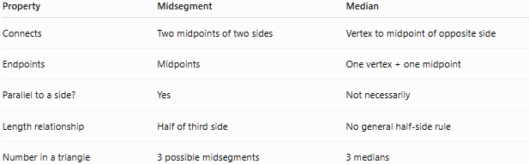
Property | Midsegment | Median
Connects | Two midpoints of two sides | Vertex to midpoint of opposite side
Endpoints | Midpoints | One vertex + one midpoint
Parallel to a side? | Yes | Not necessarily
Length relationship | Half of third side | No general half-side rule
Number in a triangle | 3 possible midsegments | 3 medians

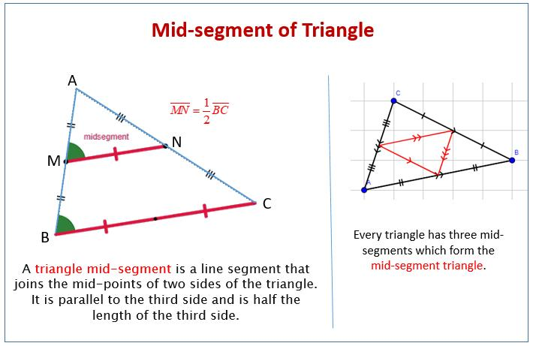
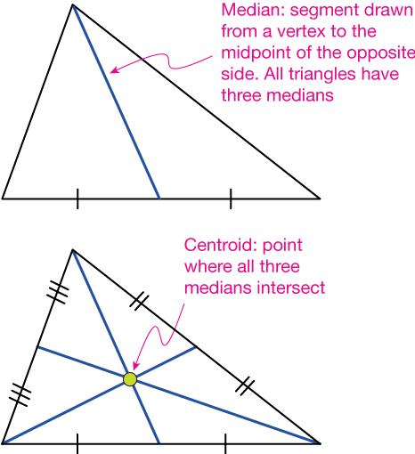

Midsegment vs Angle Bisector
# Source: AI Source: Provided by: [Data Path: Persons Table -> ID Column: 1, Name_En Column: Motasem Essam] -> From: [ChatGPT] on [7/25/2026]
A midsegment should also not be confused with an angle bisector.
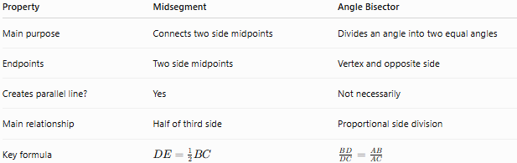
Property | Midsegment | Angle Bisector
Main purpose | Connects two side midpoints | Divides an angle into two equal angles
Endpoints | Two side midpoints | Vertex and opposite side
Creates parallel line? | Yes | Not necessarily
Main relationship | Half of third side | Proportional side division
Key formula | $$DE=\frac{1}{2}BC$$ | $$\frac{BD}{DC}=\frac{AB}{AC}$$

Real-World Applications
# Source: AI Source: Provided by: [Data Path: Persons Table -> ID Column: 1, Name_En Column: Motasem Essam] -> From: [ChatGPT] on [7/25/2026]
Midsegments and midpoint relationships are useful in:
- Architecture.
- Construction.
- Engineering.
- Surveying.
- Structural design.
- CAD.
- Computer graphics.
- Technical drawing.
- Mapping.
For example, a line connecting the midpoints of two sides of a triangular structural frame automatically has a parallel relationship with the third side.

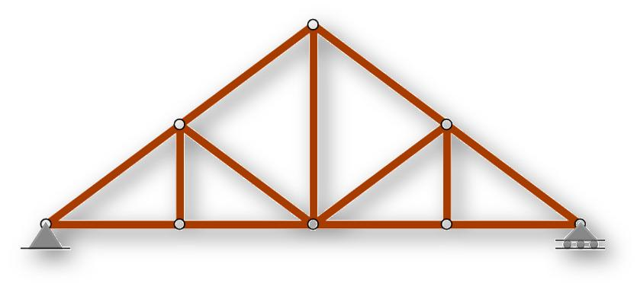



Applications
# Source: AI Source: Provided by: [Data Path: Persons Table -> ID Column: 1, Name_En Column: Motasem Essam] -> From: [ChatGPT] on [7/25/2026]
The Midsegment Theorem is important in:
- Plane Geometry
- Triangle Geometry
- Euclidean Geometry
- Similar Triangles
- Proportionality
- Parallelism
- Coordinate Geometry
- Architecture
- Engineering
- Surveying
- CAD
- Computer Graphics

Advantages
# Source: AI Source: Provided by: [Data Path: Persons Table -> ID Column: 1, Name_En Column: Motasem Essam] -> From: [ChatGPT] on [7/25/2026]
The theorem helps to:
- Find unknown lengths quickly.
- Prove that two lines are parallel.
- Identify midpoints.
- Establish similar triangles.
- Simplify geometric proofs.
- Solve proportionality problems.
- Analyze triangular structures.

Limitations
# Source: AI Source: Provided by: [Data Path: Persons Table -> ID Column: 1, Name_En Column: Motasem Essam] -> From: [ChatGPT] on [7/25/2026]
The Midsegment Theorem:
- Applies specifically to triangles.
- Requires the endpoints of the segment to be midpoints of two sides.
- The half-length relationship applies to the third side.
- A segment connecting arbitrary points on two sides is not necessarily a midsegment.
- The parallel relationship depends on the midpoint conditions.

Comparison with Related Theorems
# Source: AI Source: Provided by: [Data Path: Persons Table -> ID Column: 1, Name_En Column: Motasem Essam] -> From: [ChatGPT] on [7/25/2026]
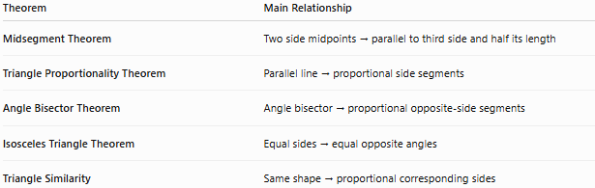
Theorem | Main Relationship
Midsegment Theorem | Two side midpoints → parallel to third side and half its length
Triangle Proportionality Theorem | Parallel line → proportional side segments
Angle Bisector Theorem | Angle bisector → proportional opposite-side segments
Isosceles Triangle Theorem | Equal sides → equal opposite angles
Triangle Similarity | Same shape → proportional corresponding sides

Key Points
# Source: AI Source: Provided by: [Data Path: Persons Table -> ID Column: 1, Name_En Column: Motasem Essam] -> From: [ChatGPT] on [7/25/2026]
- A midsegment connects the midpoints of two sides of a triangle.
- If $D$ and $E$ are midpoints:
$\boxed{AD=DB}$ $\boxed{AE=EC}$
- The midsegment is parallel to the third side:
$$\boxed{DE∥BC}$$
- The midsegment is half the length of the third side:
$$\boxed{DE=\frac{1}{2}BC}$$
- Therefore:
$$\boxed{BC=2DE}$$
- The smaller triangle and original triangle are similar:
$$\boxed{△ADE∼△ABC}$$
- A triangle has three possible midsegments.
- The three midsegments form the medial triangle.

Conclusion
# Source: AI Source: Provided by: [Data Path: Persons Table -> ID Column: 1, Name_En Column: Motasem Essam] -> From: [ChatGPT] on [7/25/2026]
The Midsegment Theorem states that a segment connecting the midpoints of two sides of a triangle is parallel to the third side and has half its length:
$$\boxed{DE∥BC}$$
and:
$$\boxed{DE=\frac{1}{2}BC}$$
The theorem follows from triangle proportionality and similar triangles and provides a simple way to establish parallelism and calculate lengths. It is an important concept in plane geometry, triangle geometry, proportionality, similarity, coordinate geometry, architecture, engineering, and geometric construction.

